Buddy Benches Benefit School Playgrounds

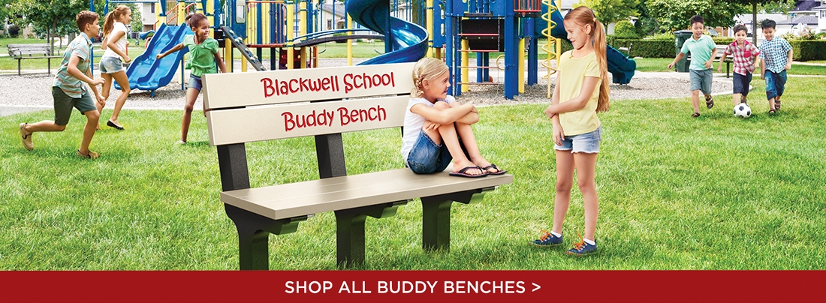
It's recess! Kids are screaming and balls are flying. Then you take a closer look, and find that some kids aren't joining in on the fun.
Christian Bucks, a 2nd grader at Roundtown Elementary School, witnessed lonely classmates at his school's playground, and wanted to make sure everyone had a friend. His solution? The Buddy Bench – modeled after a bench he saw in a German school brochure.
If you are sitting on the bench …
You are looking for a friend. When someone asks you to play, join them, and always remember to glance over at the school's Buddy Bench to invite new friends to join in on the fun.

If you are not sitting on the bench …
Ask your classmate on the buddy bench to play, and make a new friend today! Keep growing your circle of friends until everyone has someone to play with. :)
1. If you are new to the school.
2. If you want to make new friends.
3. If your friends aren't at school that day.
4. If you want to play something different than what your friend is playing.
Every seven minutes a child is bullied, according to an estimate by the U.S. Department of Justice. Promote inclusion – don't let your school's playground be a statistic. Give students a safe space to eliminate loneliness and foster friendships.

